Nicole Gallo

D597 – Database Management

May 23, 2025

MKN1 Task 1: Relational Database Design and Implementation

Table of Contents

Part 1: Design Document 2

A1: Business Problem 2

A2: Proposed Data Structure 2

A3: Database Justification 3

A4: Data Utilization 4

B: Logical Data Model 5

C: Database Objects 5

D: Scalability Strategies 5

E: Privacy & Security Measures 6

Part 2: Implementation 7

F1 – Write script to create a database instance named “D597 Task 1” using SQL 7

F2 – Write script to import the data records from the Scenario 2 CSV file into the D597 database 8

F3 – Write script for three queries to retrieve specific information from EcoMart database. 11

F4 - Apply optimization techniques to improve the run time of your queries from part F3, providing output results via a screenshot. 14

Part 3: Presentation 21

# **Part 1: Design Document**

## **A1: Business Problem**

EcoMart faces challenges managing diverse sustainability attributes across their product offering from eco-friendly vendors. This limits their commitment to providing, promoting, and connecting sustainability and environmental consciousness to consumers.

EcoMart is looking to create a database to support their business goals and values by addressing these problems:

* Lacking platform scalability and flexibility for their consumers
* Inconsistent tracking of sustainability certifications
* Difficulty linking eco-friendly products to verification of sustainability certifications
* Sacrificing platform speed and reliability for consumers

## **A2: Proposed Data Structure**

To solve these problems, EcoMart will adopt a **relational database** that highlights the following tables, entities, and attributes:

Product Table - *Products*

* ProductID (Integer) - PK
* ProductName (Varchar)
* ProdDescription (Varchar)
* Price (Decimal 10,2)
* CategoryID (Integer) – FK
* BrandID (Integer) - FK
* CategoryName (Varchar)

Customer Table - *Customers*

* CustomerID (Integer) - PK
* CustomerName (Varchar)
* CustomerPhone (Varchar)
* CustomerEmail (Varchar)

Categories Table – *Categories*

* CategoryID (Integer) – PK
* CategoryName (Varchar)

Brands Table – *Brands*

* BrandID (Integer) - PK
* BrandName (Varchar)

Orders Table – *Orders*

* OrderID (Integer) - PK
* CustomerID (Integer) - FK
* OrderDate (Date)
* OrderStatus (Varchar)
* TotalAmount (Decimal 10,2)

Order Details Table – *OrderDetails*

* OrderDetailID (Integer) - PK
* OrderID (Integer) - FK
* ProductID (Integer) - FK
* Quantity (Integer)
* UnitPrice (Decimal 10,2)

Reviews Table – *Reviews*

* ReviewID (Integer) - PK
* CustomerID (Integer) - FK
* ProductID (Integer) - FK
* Rating (TinyInteger)
* ReviewText (Varchar)
* ReviewDate (Date)

Certifications Table – *Certifications*

* CertificationID (Integer) - PK
* CertificationName (Varchar)

Inventory Table – *Inventory*

* ProductID (Integer) – PK, FK
* StockLevel (Integer)
* ReorderLevel (Integer)

Product Certifications Table - *ProductCertifications*

* ProductID (Integer) - FK
* CertificationID (Integer) - FK

Supplier Table - *Suppliers*

* SupplierID (Integer) – PK
* ProductID (Integer) - FK
* SupplierName (Varchar)
* ProdAvailability (Boolean)
* SustainabilityCert (Boolean)

## **A3: Database Justification**

A relational database for EcoMart solves these issues by:

1. Supporting **complex relationships** between entities such as, products, certifications, customers, suppliers, etc.
2. Enforcing **ACID compliance (atomicity, consistency, isolation, durability)** and **data integrity** for accurate inventory/sustainability updates
3. Enabling **OLAP (online analytical processing) queries** for flexibility and high-quality data reporting
4. Providing **scalability and performance optimization** for past, current, and new orders, products and customers.

## **A4: Data Utilization**

The data utilization for EcoMart is as follows:

* **Product discovery** – the ability for customers to search and filter through products using entities such as, categorization, certification, availability, and price.
* **Order processing** – the system can track customer orders, inventory updates, and fulfillment details.
* **Customer engagement** – the process of submitting reviews and ratings for product support
* **Sustainability analytics** – the ability to analyze eco-friendly trends and certification statuses

## **B: Logical Data Model**

Entity-Relationship Diagram for EcoMart

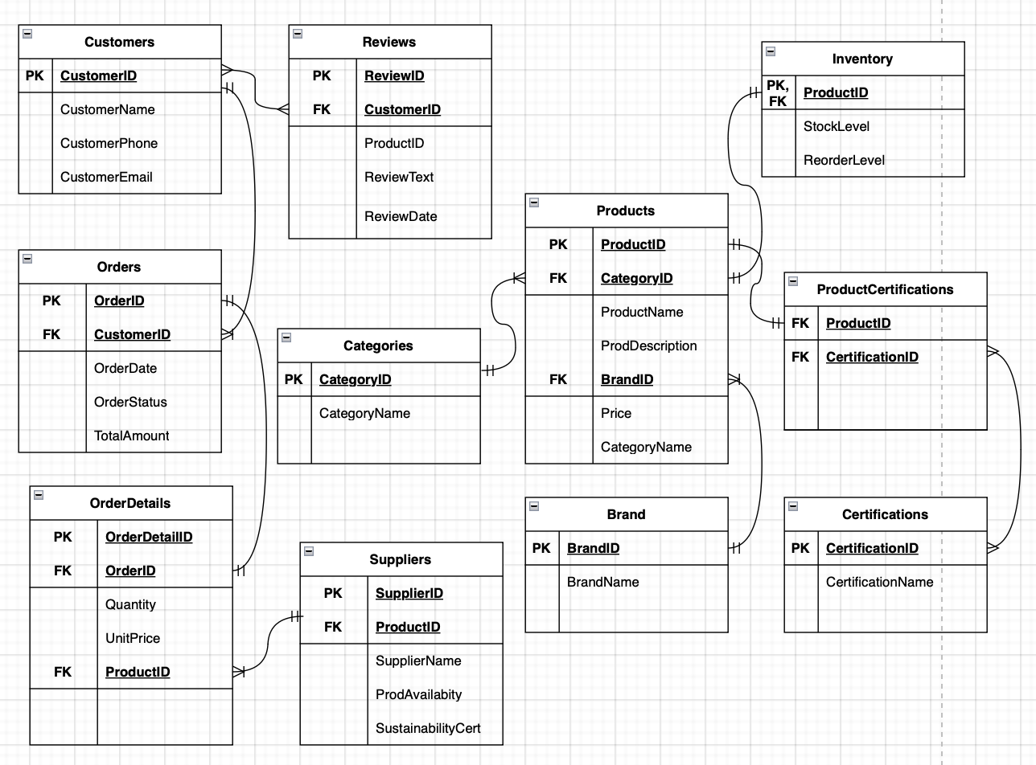

## **C: Database Objects**

The database for EcoMart will contain the following:

* **Tables** – this database object is how rows and columns will be stored
* **Indexes** – this database object is used to optimize queries so the performance is enhanced
* **Views** – this database object is for simplifying complex queries to support data presentation

The files within the database will store attributes such as data tyles, default values, constraints, and if an attribute is NULL or NOT NULL.

## **D: Scalability Strategies**

To support scalability and future growth, we will use the following strategies:

* **Denormalization** – Combining and adding necessary information amongst tables such as creating CategoryName and SupplierName directly into the Products table.
* **Horizontal Scaling (Sharding)** – Dividing the order and supplier data into geographic regions or time zones to support high volumes of orders and shipping.
* **Vertical Scaling** – Increasing resources to servers such as expanding storage to be able to handle more orders in the future while keeping a log of past and current orders in the database.
* **Caching** – Implementing caching for specific “every day” queries such as finding most sold products or products with certifications. This will save time spent on rewriting popular queries.

## **E: Privacy & Security Measures**

The privacy and security measures that should be implemented are as follows:

1. **Data Protection (Encryption):**
   1. Sensitive data like customer information (contact info, billing, etc.) needs to be encrypted and protected from possible data breaches.
2. **Access Control**:
   1. Assignment of roles such as a “sustainability auditor” should be implemented to restrict data visibility on specific and relevant tables
3. **Compliance:**
   1. There are laws that deal with storing and handling personal information and data. There needs to be compliance checks in place to ensure these laws (GDPR, PCI-DSS, etc.) are being upheld.
4. **Monitoring:**
   1. The monitoring of data is important because as EcoMart grows, it’s more susceptible to cyber-attacks and threats
   2. There should be an implementation for real-time alerting for suspicious queries, such as bulk supplier data exports.

# **Part 2: Implementation**

## **F1 – Write script to create a database instance named “D597 Task 1” using SQL**

## **F2 – Write script to import the data records from the Scenario 2 CSV file into the D597 database**

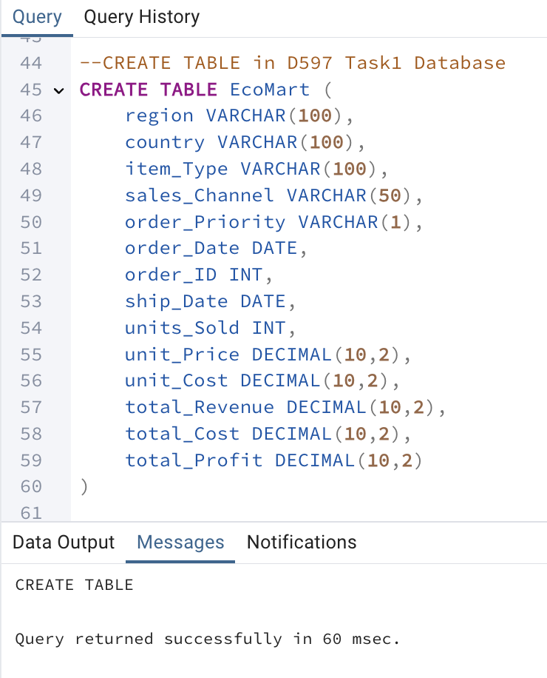

COPY data from CSV file

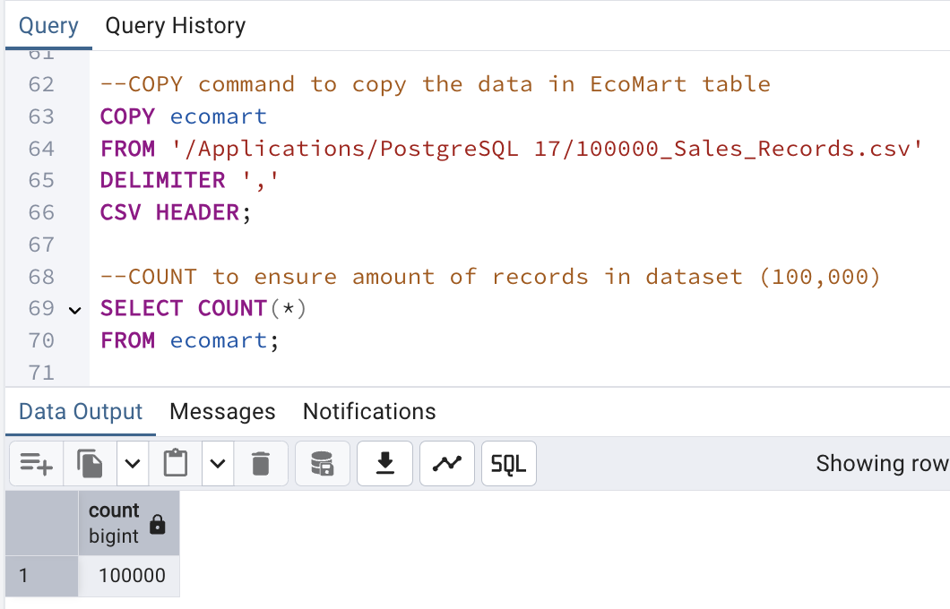

SELECT the entire dataset for EcoMart

INSERT INTO command to insert new data entry (new order)

## **F3 – Write script for three queries to retrieve specific information from EcoMart database.**

### Q1 – What are the top 5 products by total profit?

### Q2 – What is the average delivery time by sales channel?

### Q3 – What is the total revenue by region?

## **F4 - Apply optimization techniques to improve the run time of your queries from part F3, providing output results via a screenshot.**

### Creating indexes for the frequently used columns (item types, regions, order dates, sales channel)

### 2. Creating VIEWs to store summary tables for Total Revenue by Region, Top Profit Products, Avg Delivery Time by Sales Channel

#### Q1- Create a view for Total Revenue by Region

Before Optimization (Q1 - Total Revenue by Region):

After Optimization (Q1 - Total Revenue by Region):

#### Q2 – Create a view for Top Profit Products

Before Optimization (Q2 - Top Profit Products):

After Optimization (Q2 - Top Profit Products):

#### Q3 – Create a view for Avg Delivery Time by Sales Channel

Before Optimization (Q3 – Avg Delivery Time by Sales Channel):

After Optimization (Q3 – Avg Delivery Time by Sales Channel):

# **Part 3: Presentation**

<https://wgu.hosted.panopto.com/Panopto/Pages/Viewer.aspx?id=3bbaee3a-35a0-4df7-a9b4-b2f601285033>

**H: Sources**

No external sources were referenced throughout this submission.